**AIO- The All-in-one Place**

Portal 1

**Version:** 1.0.0

**Status:** In development

**Goal:** To devise a tailored solution for small-scale businesses, with the objective of amplifying their visibility and bolstering their income.

**Description:** Welcome to AIO Portal 1- the platform built for local businesses to showcase their range of products.

* For businesses
* Create your own e-commerce shop in less than 15 minutes.
* Upload your products in an easy-to-use interface in any format that best suits your needs.
* Create personalized communities to share offers/discounts to all the customers.
* Get key performance stats like views, sales and revenue in a listing overview.
* For customers
* Join customized communities and meet like-minded people all around the world
* Buy from your local stores in an easy-to-use and secure way.
* Chat with shop-owners directly and give personalized orders.

**Tools used:**

* EJS
* CSS
* JavaScript
* Node.js
* Express.js
* Google Firebase
* Socket.IO

**Installation Instruction:**

1. Install Node.js from [here](https://nodejs.org/en/download).
2. 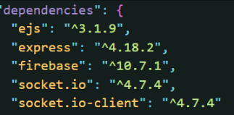Install dependencies:

npm install <name>@<version>

1. Download source code from GitHub

**Features:**

* Real-time room searching

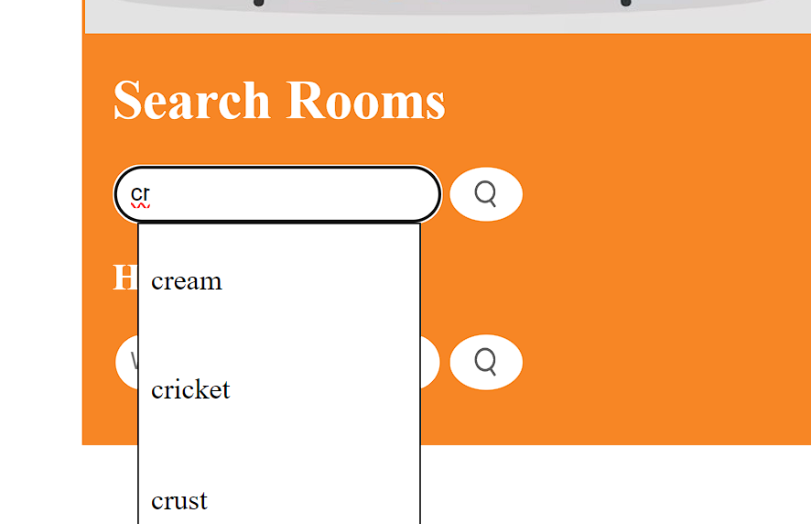

* 24/7 Support



* Easy to use interface

